GoNoGo Heat Map®

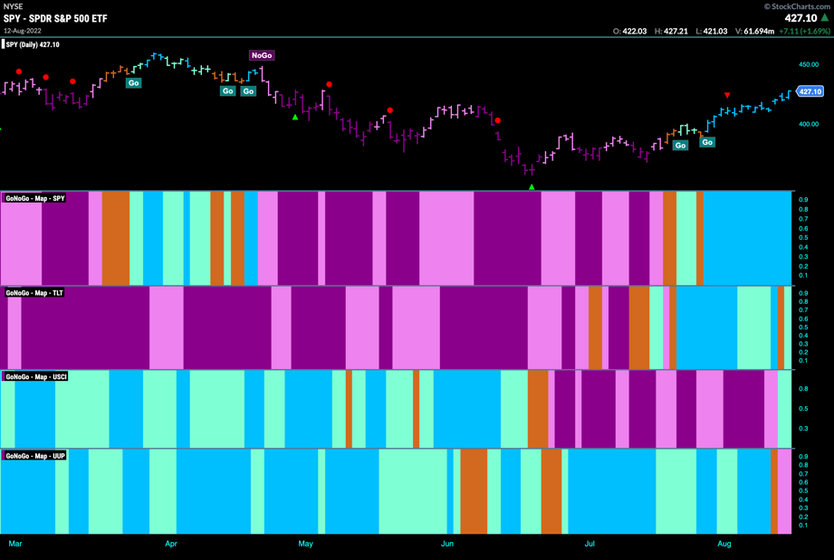
Cross-Asset Comparison of GoNoGo Trend
- Equities continue to paint strong blue “Go” bars this week
- $TLT shows treasury finish the week painting an aqua “Go” bar
- Commodities end the week with a return to an aqua “Go” bar
- Dollar paints pink “NoGo” bars to end the week

GoNoGo RelMap®
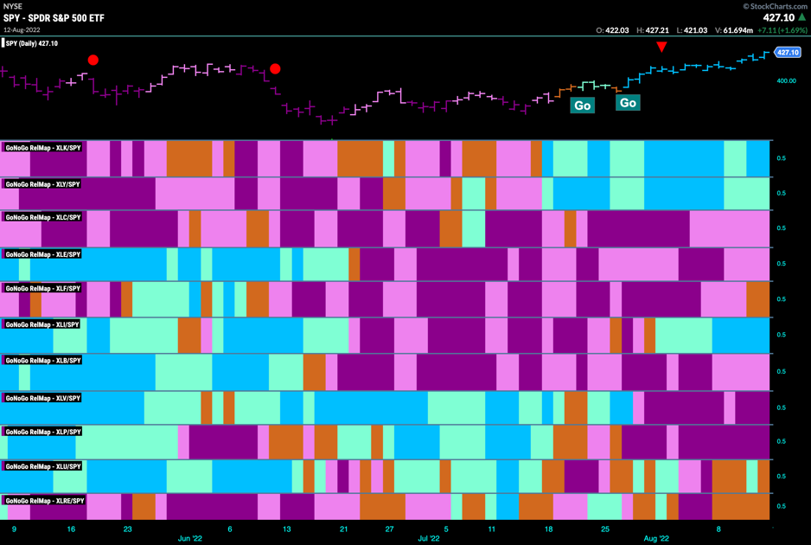
GoNoGo Trend of Sectors’ Relative Strength to $SPX

- 3 sectors outperformed the broad S&P 500 Index to end this week
- $XLK, $XLY, and $XLI are the only sectors in “Go” trends on a relative basis
- “NoGo” trends persist in $XLE, $XLB and $XLV and $XLP

Fixed Income

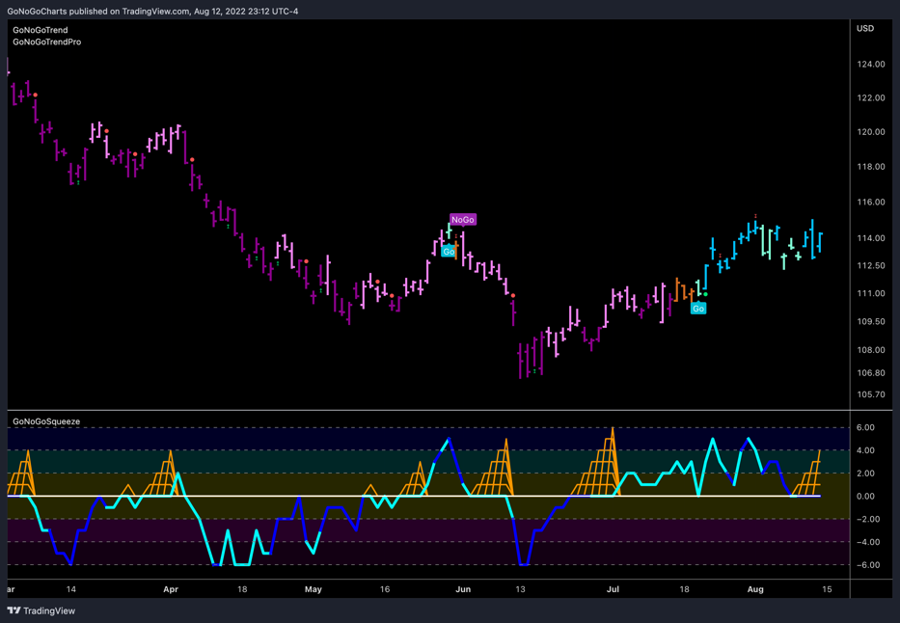
Investment Grade Corporate Bonds - $LQD
- GoNoGo Trend continued strength as GoNoGo Trend moves into strong blue “Go” bars
- GoNoGo Oscillator is riding the zero line as a GoNoGo Squeeze builds

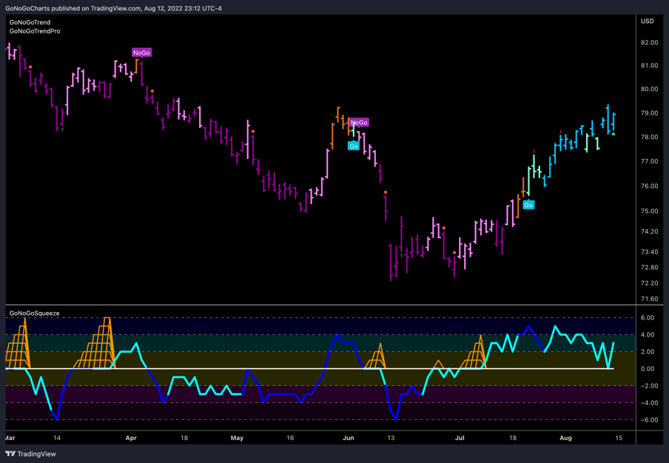
High Yield Bonds - $HYG
- The GoNoGo Trend shows strong “Go” bars this week
- GoNoGo Oscillator has found support at the zero line

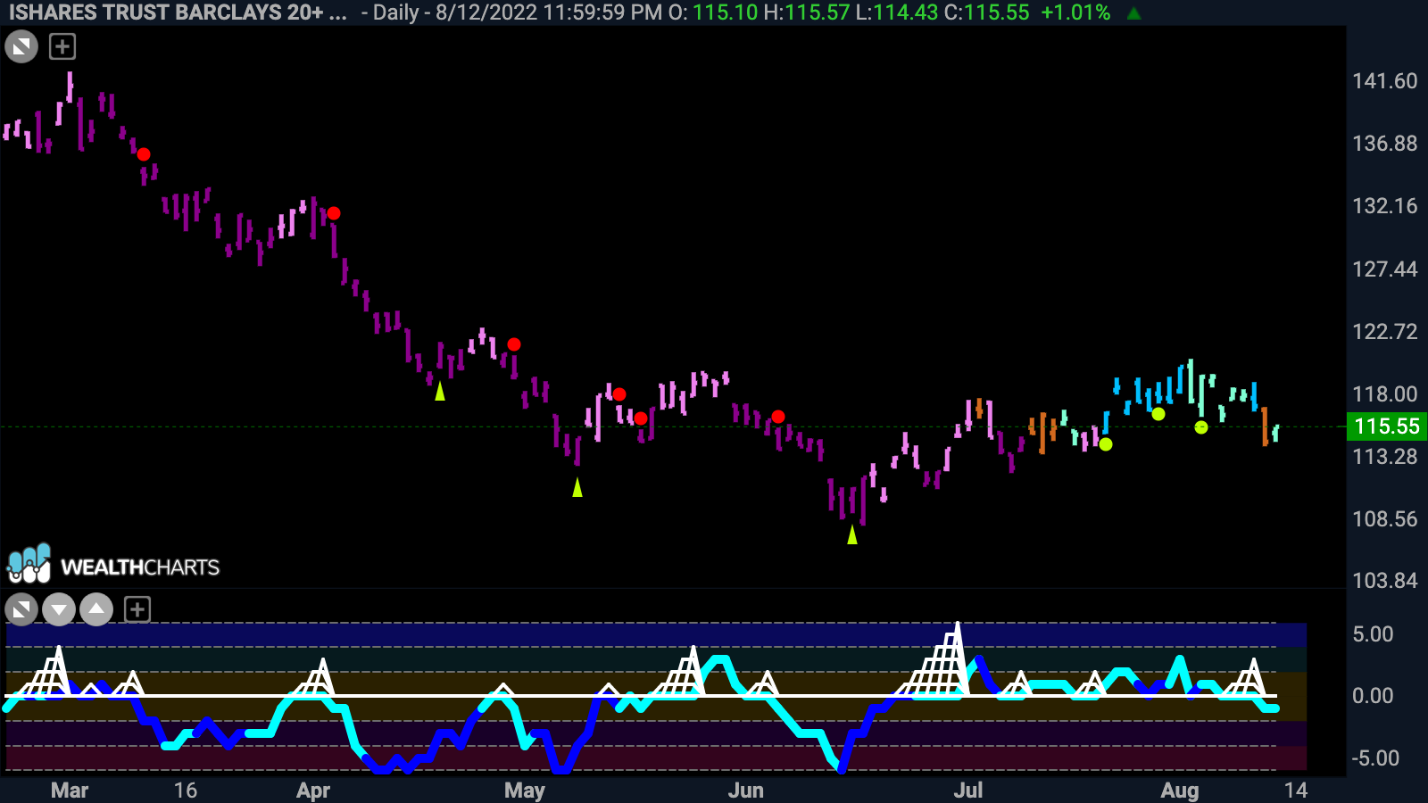
Government Treasury Bonds - $TLT
- GoNoGo Trend ends the week with an aqua “Go” bar after one “Go Fish” bar
- GoNoGo Oscillator fails to find support at the zero line

spy Equities

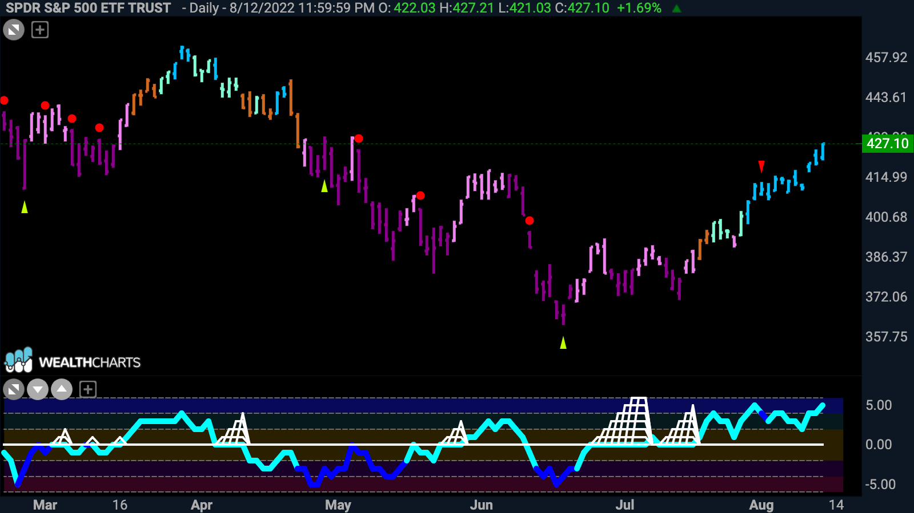
U.S. Large Cap - $SPY
- GoNoGo Trend shows price is in “Go” trend as the week closes with more strong blue bars
- GoNoGo Oscillator is in overbought territory

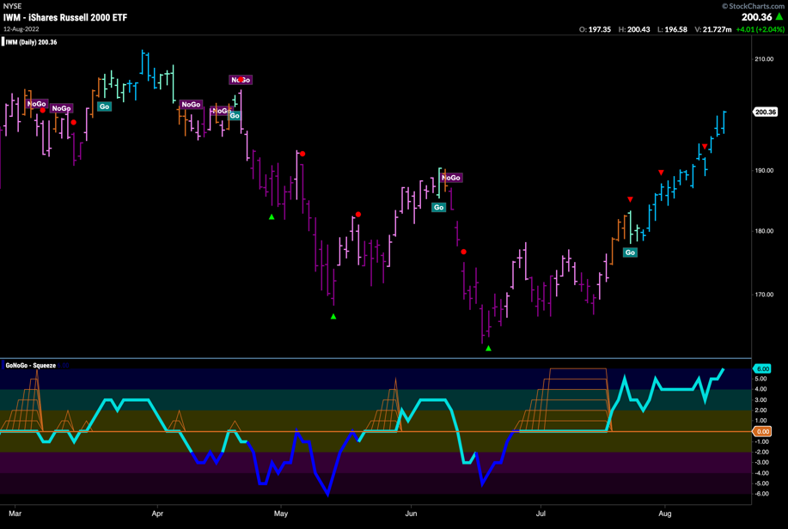
U.S. Small Cap - $IWM
- GoNoGo Trend shows a string of strong blue “Go” bars this week
- GoNoGo Oscillator remains elevated in overbought territory

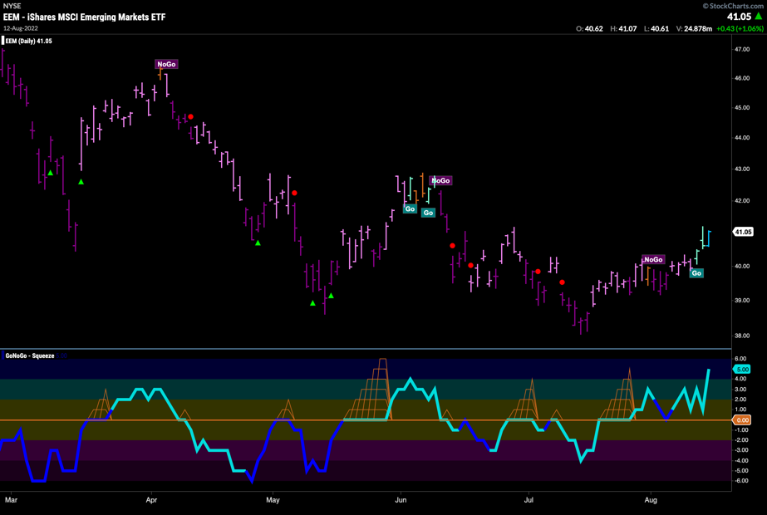
Emerging Markets - $EEM
- GoNoGo Trend shows a new “Go” trend is in place
- GoNoGo Oscillator has rallied and is now in overbought territory

Commodities

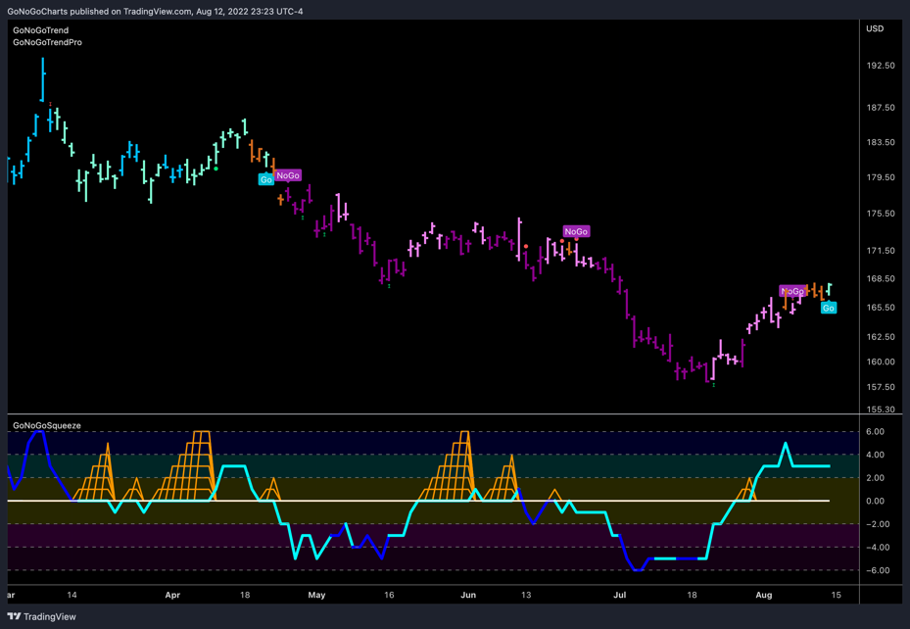
Gold - $GLD

- GoNoGo Trend shows that a new “Go” trend has been identified
- GoNoGo Oscillator is in positive territory but not overbought

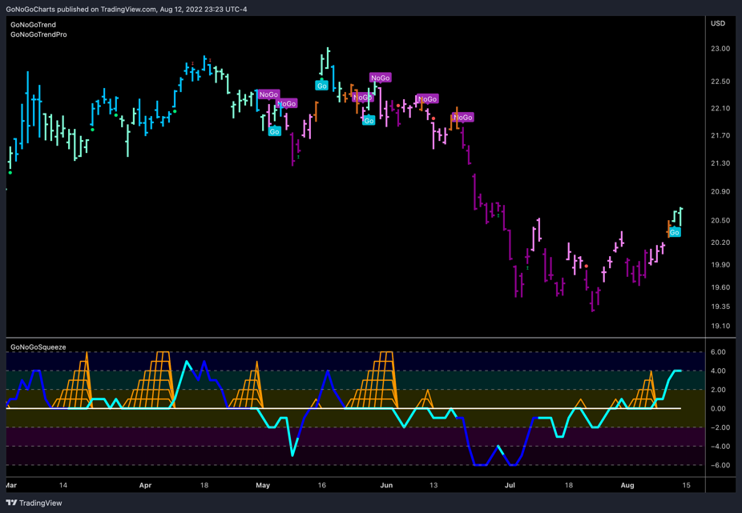
Agriculture – $DBA
- GoNoGo Trend shows a fresh “Go” trend this week with aqua bars
- GoNoGo Oscillator has rallied out of a small GoNoGo Squeeze into positive territory

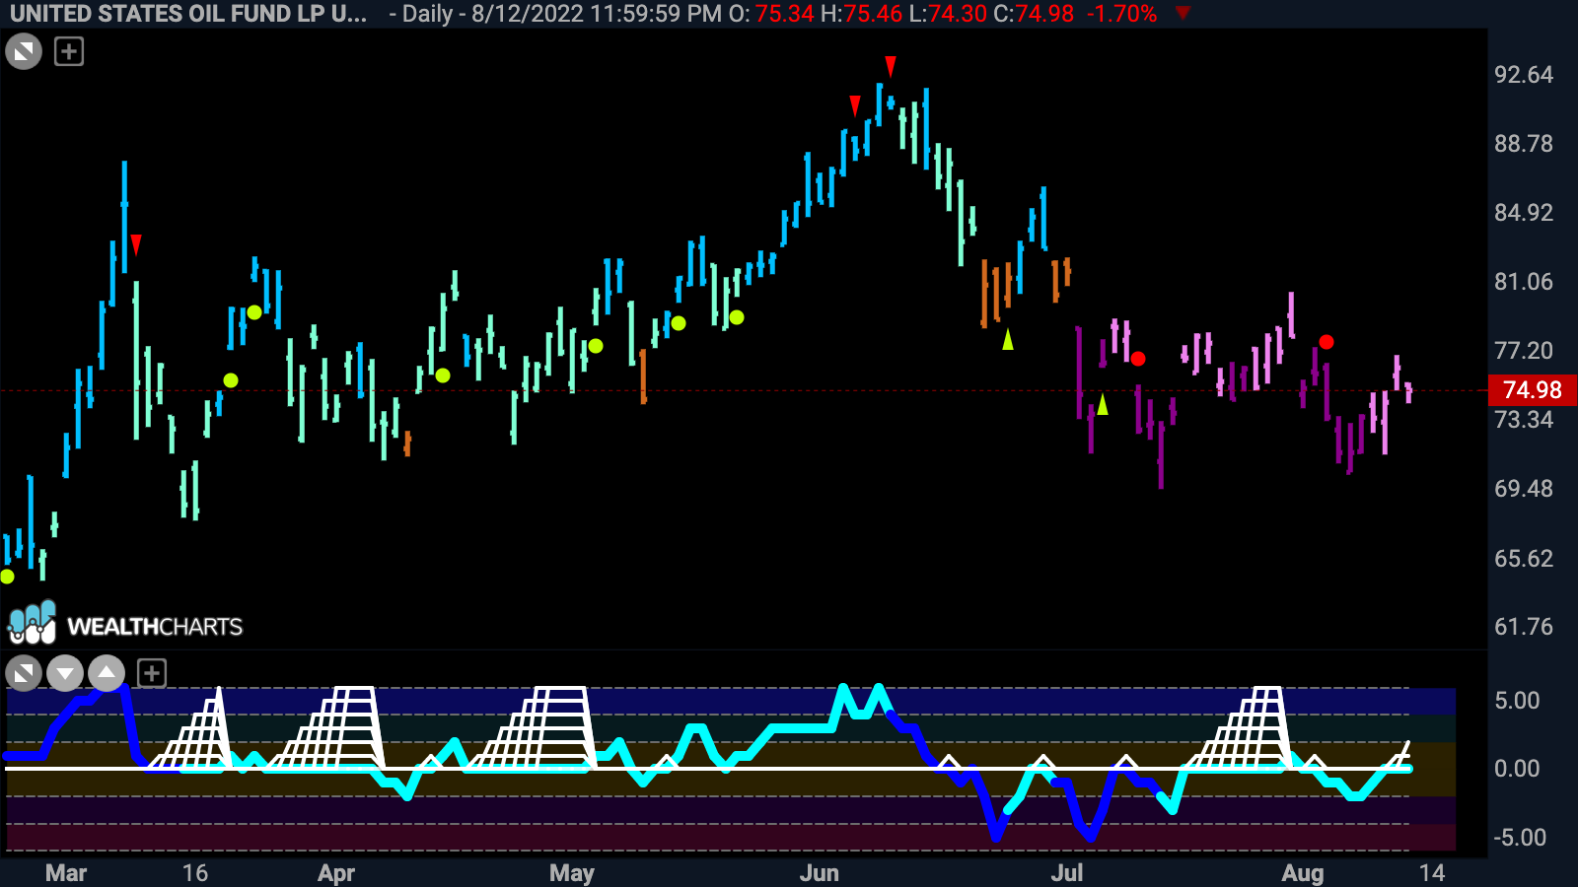
Oil - $USO
- GoNoGo Trend shows the “NoGo” remains in place but paints weaker pink bars
- GoNoGo Oscillator continues to find resistance at the zero line and is testing it once again from below

Currencies

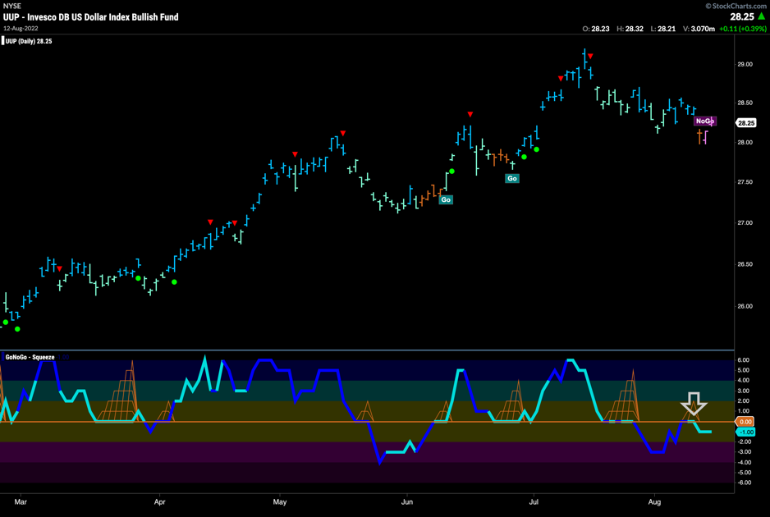
The Dollar - $UUP
- GoNoGo Trend shows a new “NoGo” trend is identified this week
- GoNoGo Oscillator has been rejected by the zero line

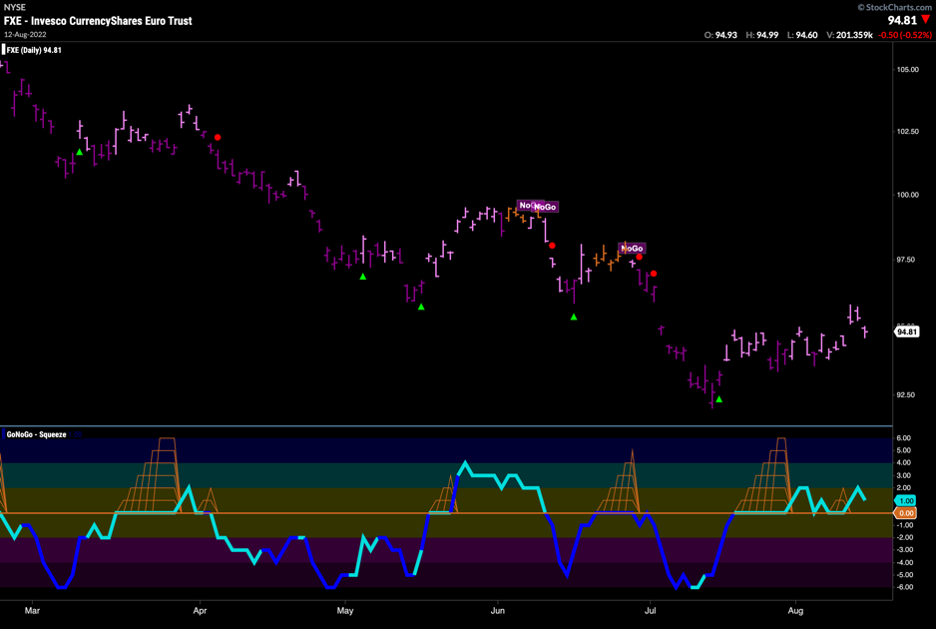
The Euro - $FXE
- GoNoGo Trend paints weaker pink “NoGo” bars as price rallies off the lows
- GoNoGo Oscillator is finding support at the zero line this week

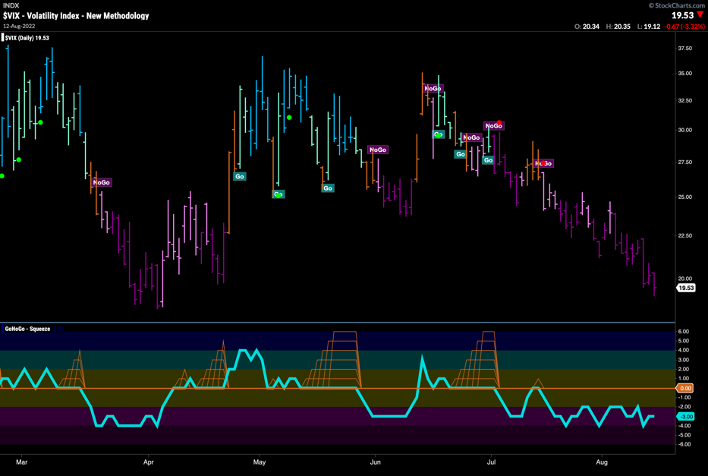
Volatility - $VIX
- Volatility paints strong purple “NoGo” bars
- GoNoGo Oscillator is in negative territory but not oversold

Cryptocurrency

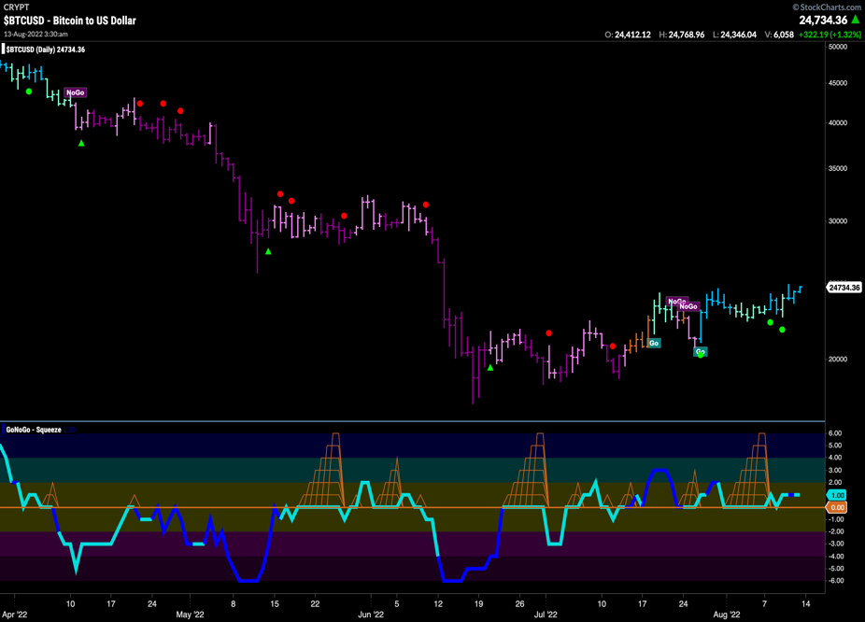
Bitcoin - $BTCUSD
- GoNoGo Trend shows the “Go” trend strengthen to strong blue bars to end the week
- GoNoGo Oscillator continues to find support at the zero line

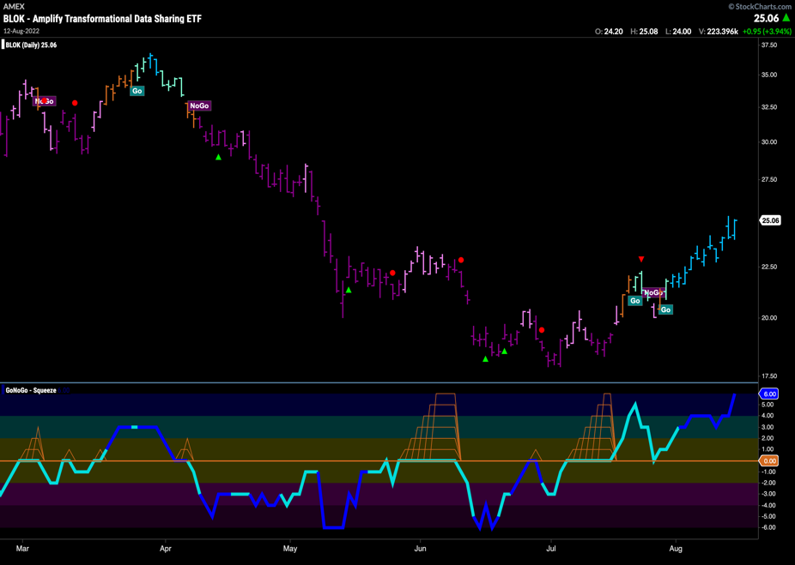
Crypto Fund - $BLOK
- GoNoGo Trend shows continued “Go” strength as we see a string of strong blue bars
- GoNoGo Oscillator is in overbought territory on heavy volume

