# GoNoGo Heat Map®

## Cross-Asset Comparison of GoNoGo Trend

* Equities sees the “Go” trend return after a few amber “Go Fish” bars
* Treasury bond prices remained in a “Go” trend and we saw a complete week of strong blue “Go” bars
* Commodities saw the “NoGo” trend continue but the week ended with a weak pink bar
* Dollar saw the “NoGo” trend remain in place and strengthen at the end of the week

# GoNoGo RelMap®

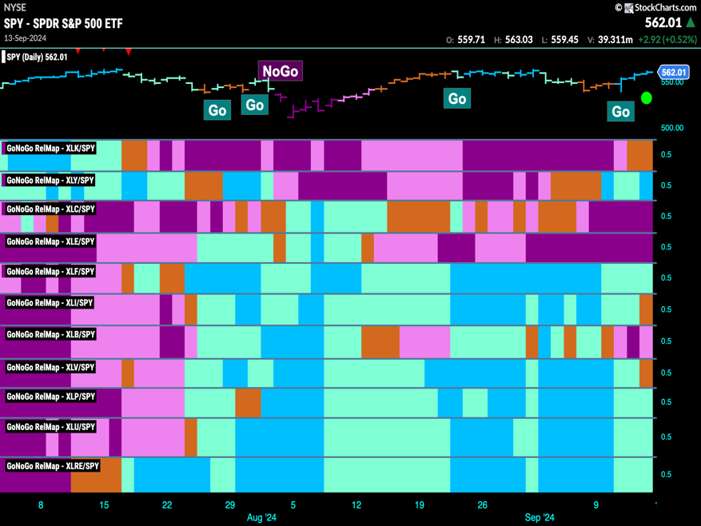GoNoGo Trend *of* Sectors’ Relative Strength to $SPX

* 5 sectors outperformed the broad S&P 500 Index to end this week
* $XLY, $XLF, $XLP, $XLU, and $XLRE are in “Go” trends on a relative basis

# Fixed Income

## Investment Grade Corporate Bonds - $LQD

* GoNoGo Trend showed that price remained in a “Go” trend and we saw new highs on strong blue bars
* GoNoGo Oscillator is in overbought territory and volume is heavy

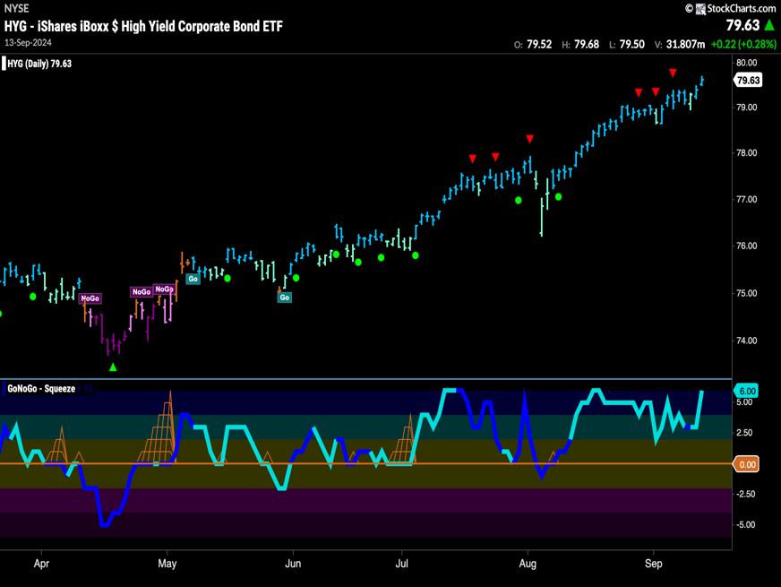High Yield Bonds - $HYG

* GoNoGo Trend saw the “Go” trend continue and price hits new highs on strong blue bars
* GoNoGo Oscillator is at an overbought extreme at a value of 6

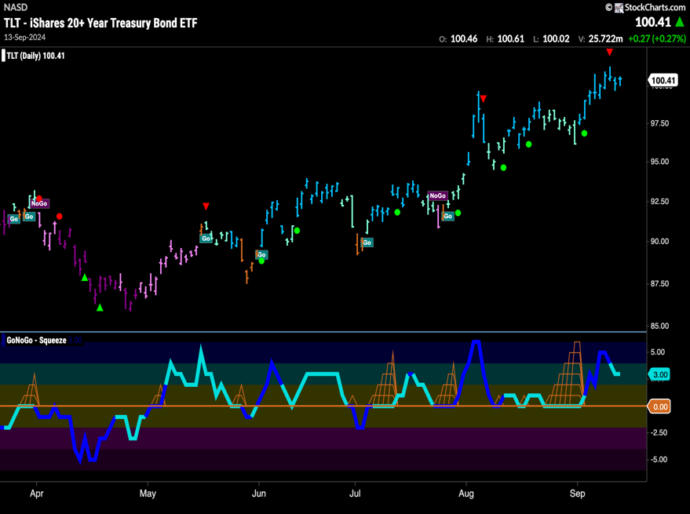Government Treasury Bonds - $TLT

* GoNoGo Trend saw the “Go” trend remain strong this week as we saw new price highs
* GoNoGo Oscillator is in positive territory but no longer overbought at a value of 3

# spy Equities

## U.S. Large Cap - $SPY

* GoNoGo Trend sees the “Go” return this week on strong blue bars as price challenges prior highs
* GoNoGo Oscillator is pushing its way back into positive terriotry

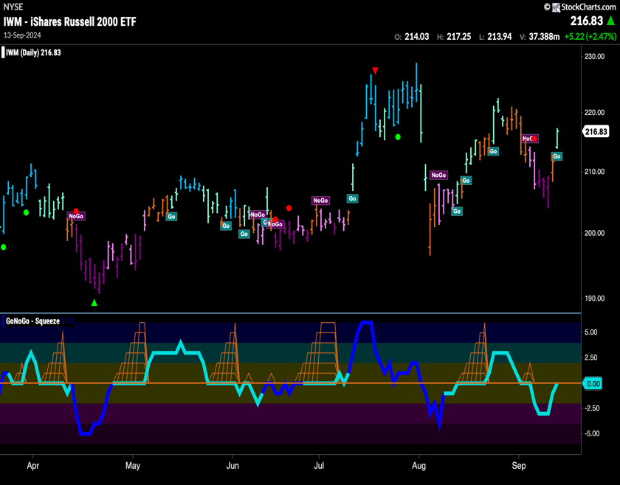U.S. Small Cap - $IWM

* GoNoGo Trend shows the “Go” trend has returned with an aqua bar
* GoNoGo Oscillator is testing the zero line from below where we will watch to see if it finds resistance

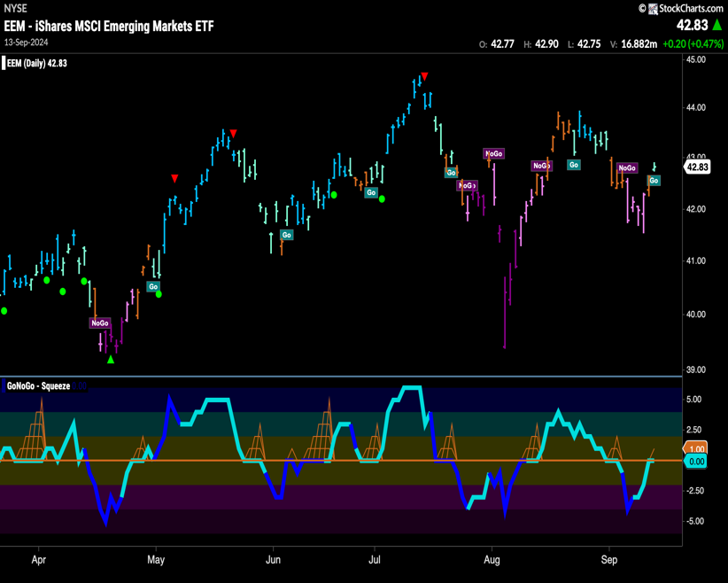Emerging Markets - $EEM

* GoNoGo Trend shows the “Go” trend returned with an aqua bar this week
* GoNoGo Oscillator is testing the zero line from below where we will watch to see if it finds resistance

# Commodities

# Gold - $GLD

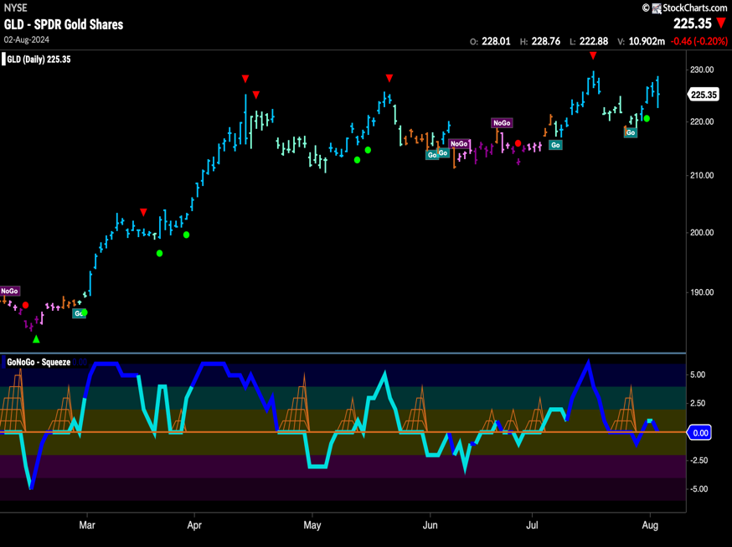

* GoNoGo Trend painted strong “Go” bars this week as price tries again to set a new high
* GoNoGo Oscillator is testing the zero line from above where we will watch to see if it finds support and volume is heavy

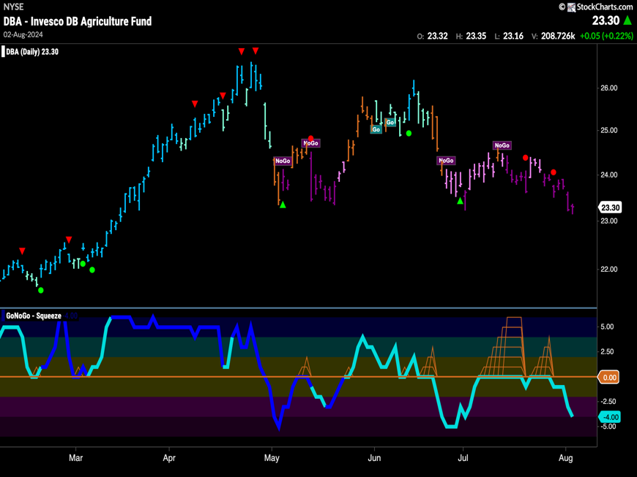Agriculture – $DBA

* GoNoGo Trend shows the “NoGo” remained strong with consecutive purple bars as price creeps to a new low
* GoNoGo Oscillator is in negative territory but not yet oversold at a value of -4

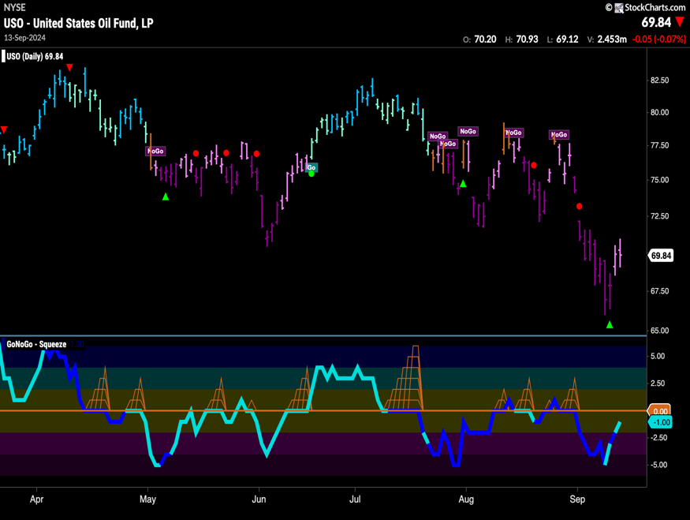Oil - $USO

* GoNoGo Trend shows the “NoGo” continues but the indicator paints weaker pink bars
* GoNoGo Oscillator is in negative territory at a value of -1 but approaching the zero line

# Currencies

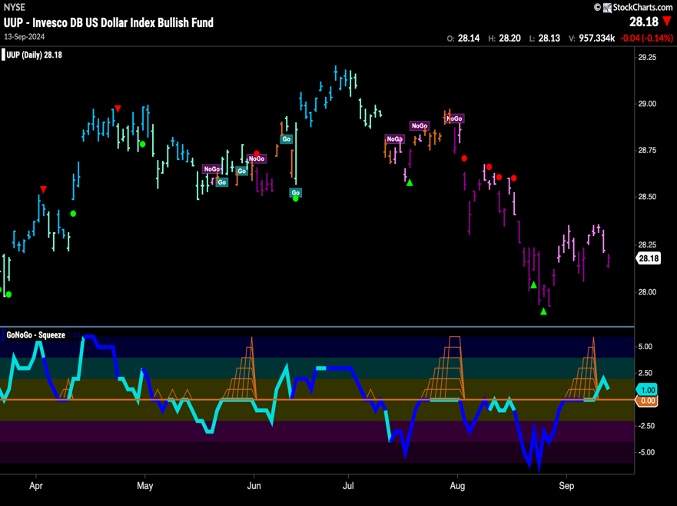The Dollar - $UUP

* GoNoGo Trend shows the “NoGo” trend continues as the indicator paints a strong purple bar at the end of the week
* GoNoGo Oscillator has broken out of a Max GoNoGo Squeeze into positive territory

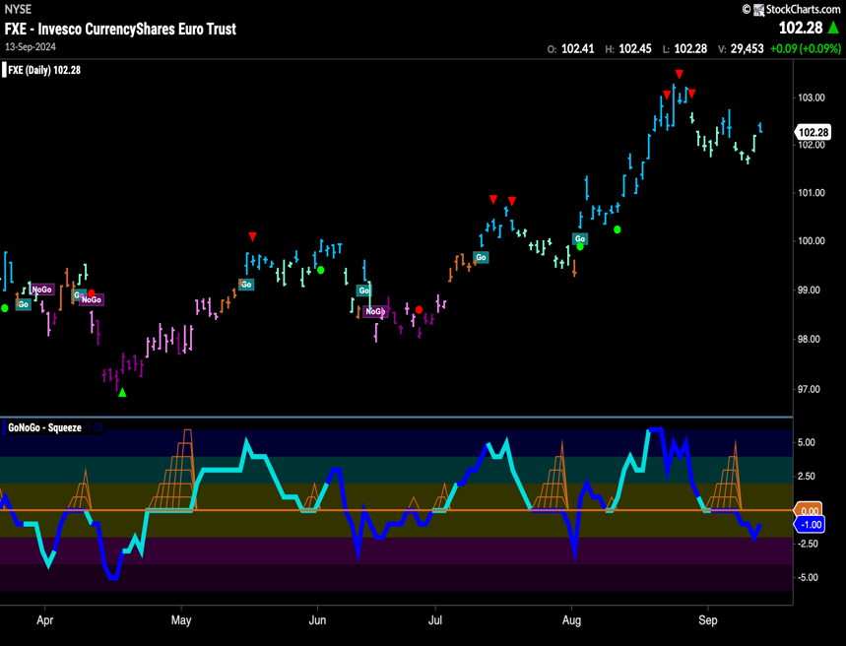The Euro - $FXE

* GoNoGo Trend shows that the “Go” trend remains as price tries to rally off lows
* GoNoGo Oscillator has broken out of a GoNoGo Squeeze into negative territory and on heavy volume

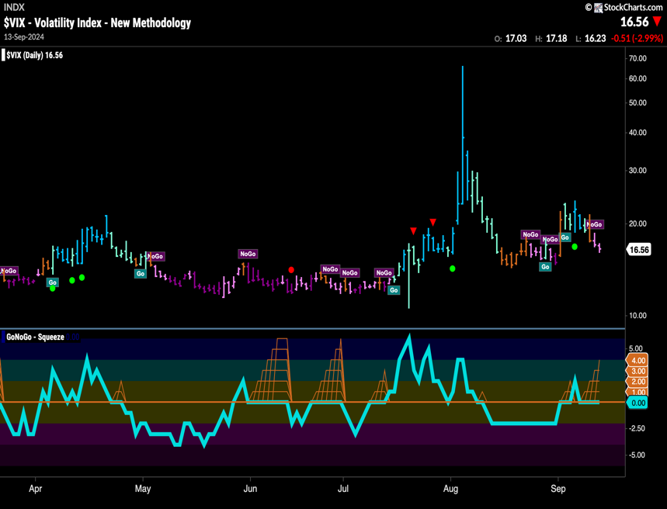Volatility - $VIX

* GoNoGo Trend shows volatility has decreased as the indicator paints weak pink “NoGo” bars
* GoNoGo Oscillator is testing the zero line as we see the beginning of a GoNoGo Squeeze

# Cryptocurrency

## Bitcoin - $BTCUSD

* GoNoGo Trend painted amber “Go Fish” bars at the end of this week as the market became uncertain about the trend
* GoNoGo Oscillator is in positive territory at a value of 1 on heavy volume

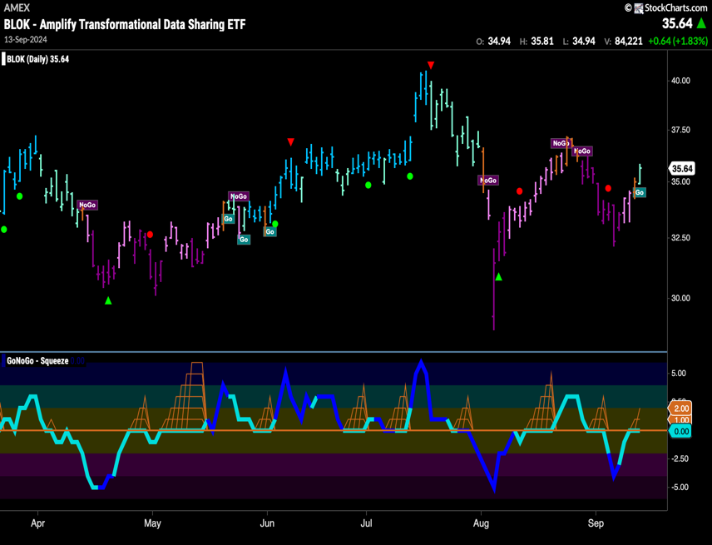Crypto Fund - $BLOK

* GoNoGo Trend shows that the trend has changed as we see a new aqua “Go” bar
* GoNoGo Oscillator is at the zero line where we will see if it gets rejected

Top 5 Stocks in “Go” Trends

## Trend Continuation on Rising Momentum

GoNoGo Charts® highlight low-risk opportunities for trend participation with intuitive icons directly in the price action. The resurgence of momentum in the direction of the underlying price trend is an excellent entry opportunity, or the chance to scale up positions.

GoNoGo Icons® illuminate these events on the chart with green solid circles (or red circle to highlight continuation of NoGo trends). When GoNoGo Trend® is painting **blue** or **aqua** bars, a green solid circle will appear below price each time GoNoGo Oscillator® finds support at zero.

#### Below are the top 5 stocks/ETFs in “Go” trends with surging momentum by volume in the S&P 500 as of the daily closing price action:

### Broadcom, Inc. – (AVGO)

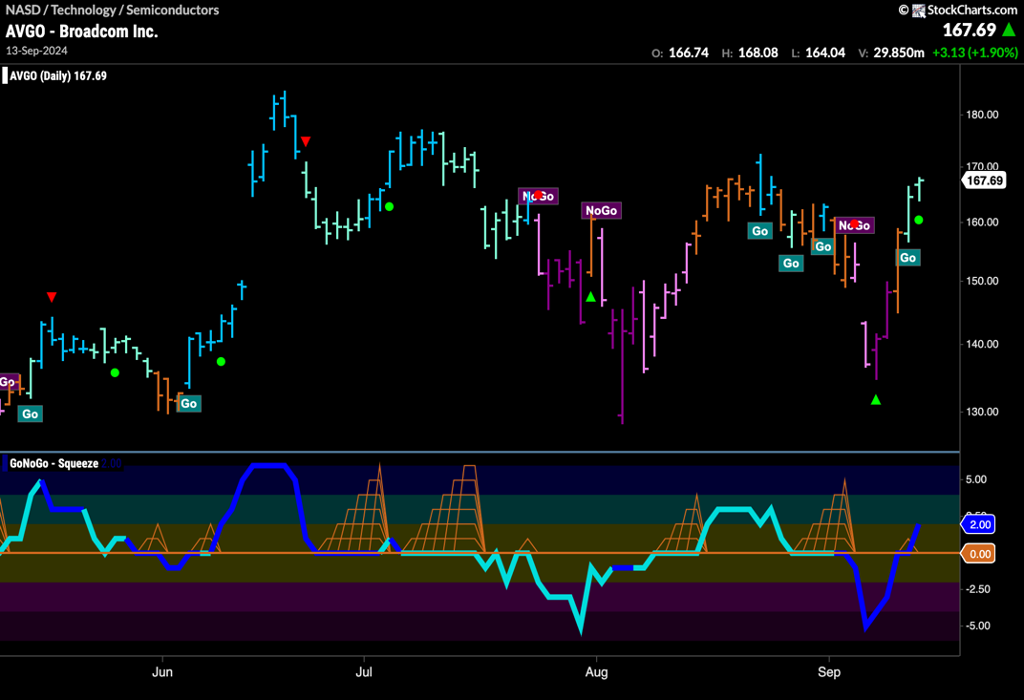

* GoNoGo Trend is painting a “Go” bar as we see signs of trend continuation as price rallies
* GoNoGo Oscillator has broken through the zero line and volume is heavy

### GE Aerospace (GE)

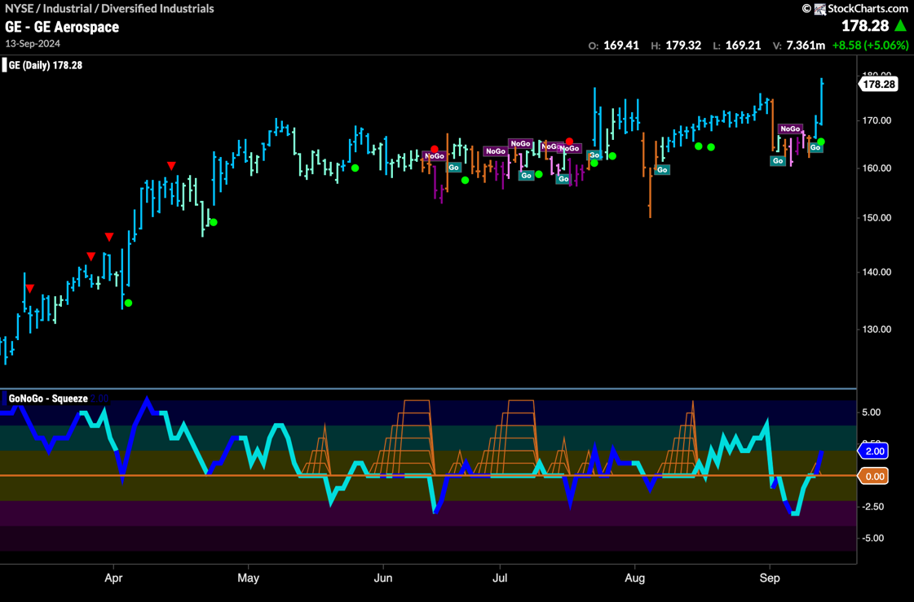

* GoNoGo Trend is painting a strong blue “Go” bar as price climbs to new high
* GoNoGo Oscillator has broken through the zero line and volume is heavy

### Vistra Energy Corp. (VST)

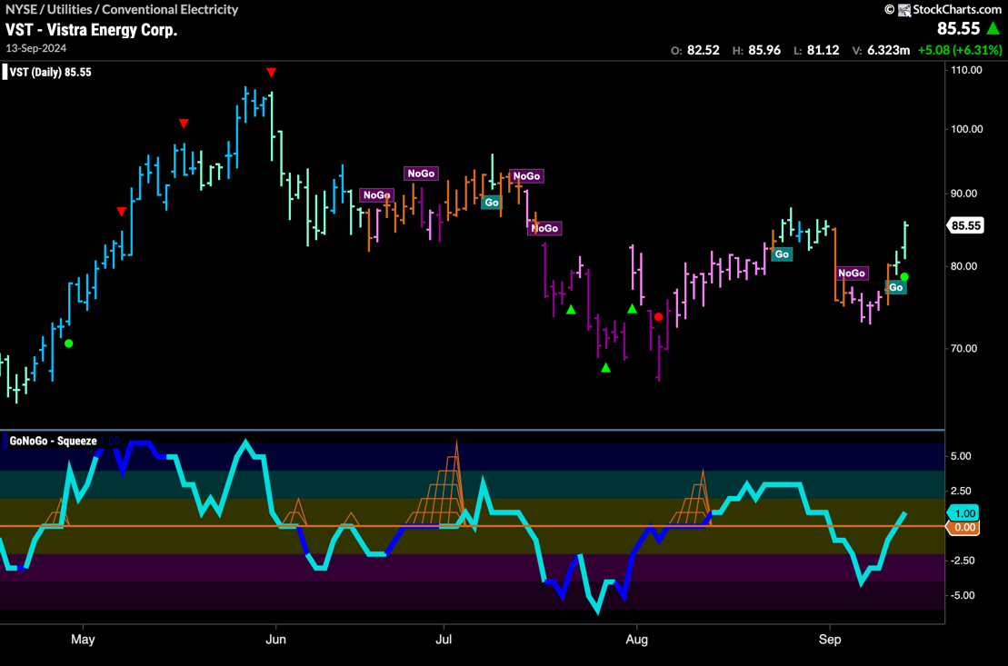

* GoNoGo Trend is painting a pink “NoGo” bar as price threatens a new low
* GoNoGo Oscillator is dipping into negative territory and volume is heavy

### Host Hotels & Resorts (HST)

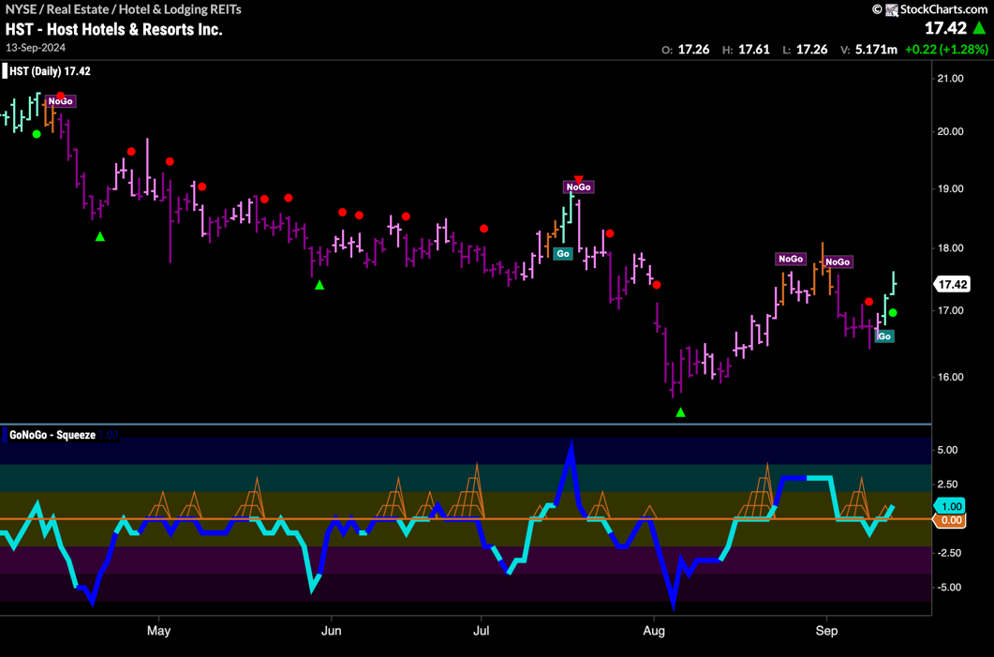

* GoNoGo Trend is painting aqua “Go” bars after price has set a new higher low
* GoNoGo Oscillator is back in positive territory at a value of 1

### Johnson Controls Intl plc (JCI)

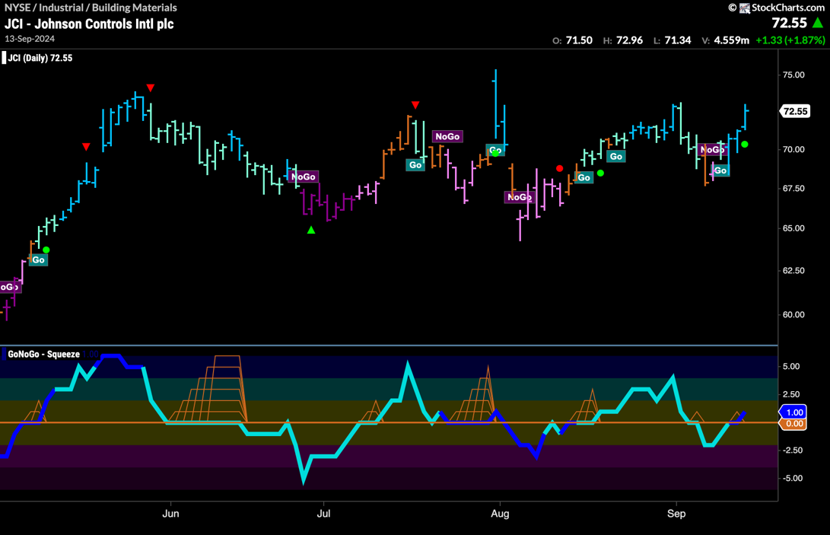

* GoNoGo Trend is painting strong blue “Go” bars as price threatens to make a new high
* GoNoGo Oscillator is creeping into positive territory and volume is heavy